**Project Planning and task management:**

We have used ScrumDo for the agile development process and the link of our ScrumDo Project is given below:

<https://www.scrumdo.com/projects/project/mcc-final-project/>

App Recommender is a team project and every member in the team learnt more knowledge in Hadoop and its ecosystems primarily. As we tried to put Apache Pig into use for this project we even learnt that apart from the HTML, JavaScript, CSS and PHP. The team also learned project management skills throughout the project development. We have used an iterative incremental process ScrumDo for the agile process development. We have planned four iterations for this project and also completed it within the planned time. The Screenshots of the ScrumDo project development are shown below.

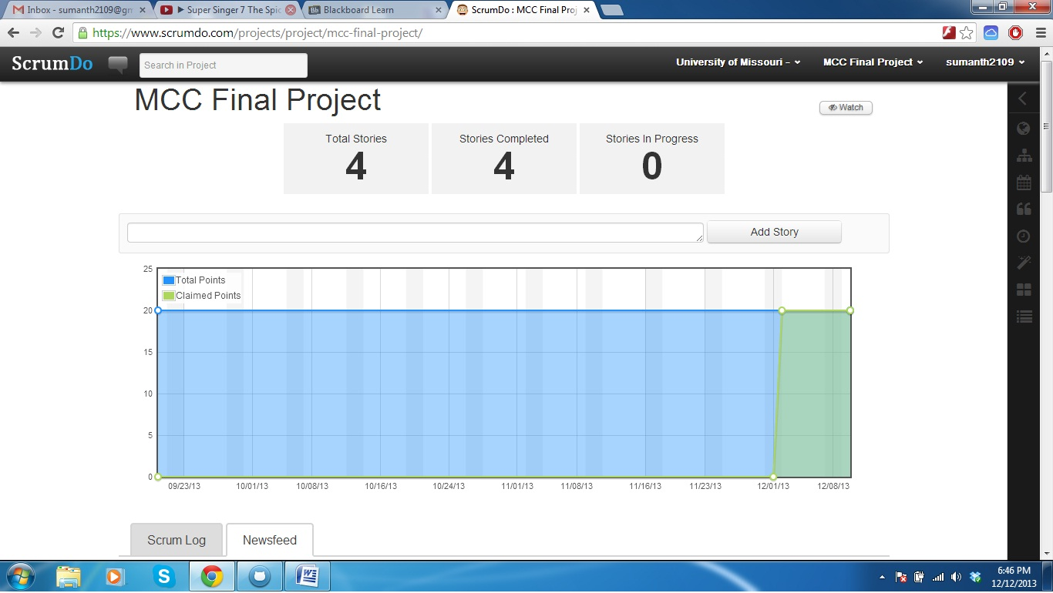

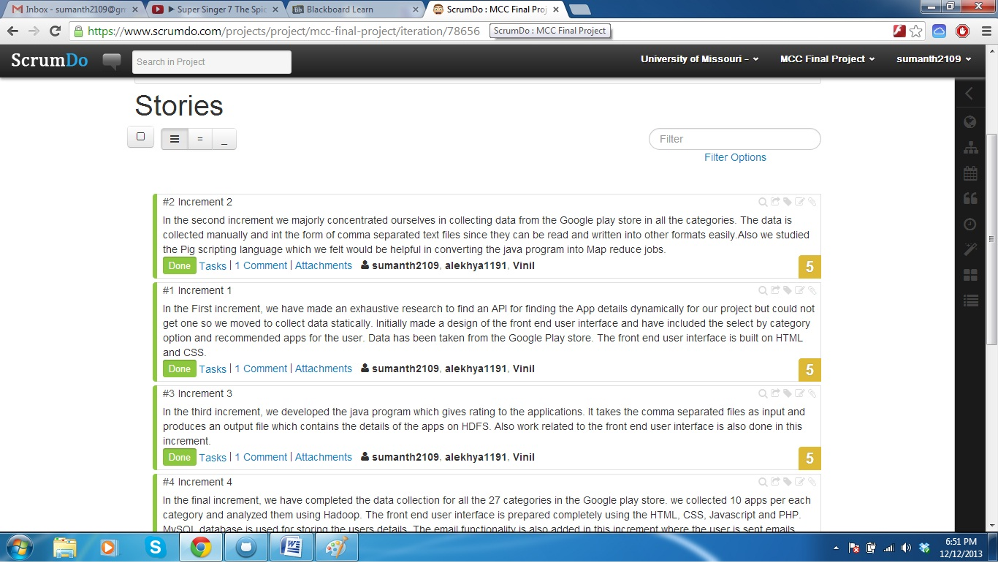

We have created four stories for the whole project and each story is completed in one increment.

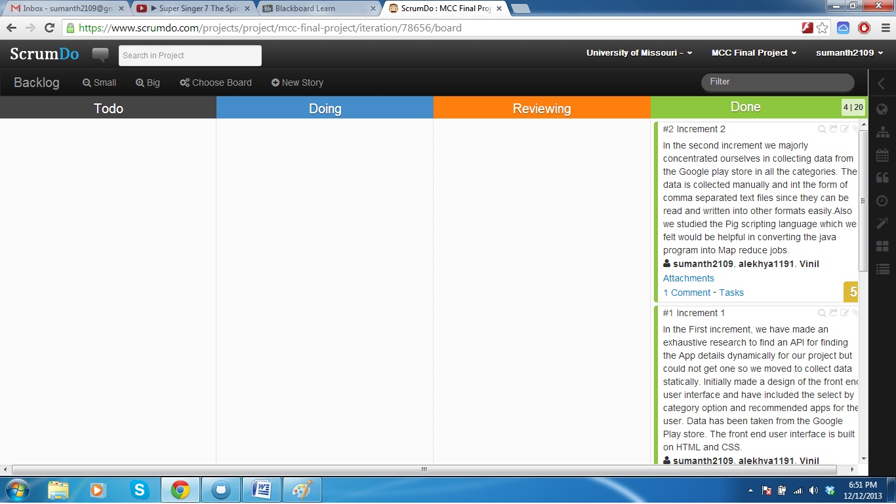

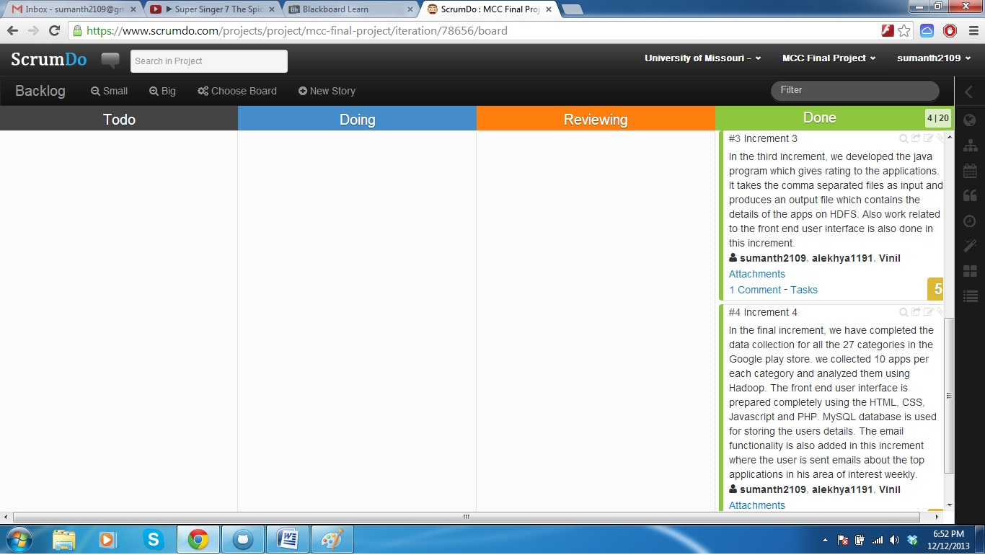

The completed stories are shown from the above screenshots.

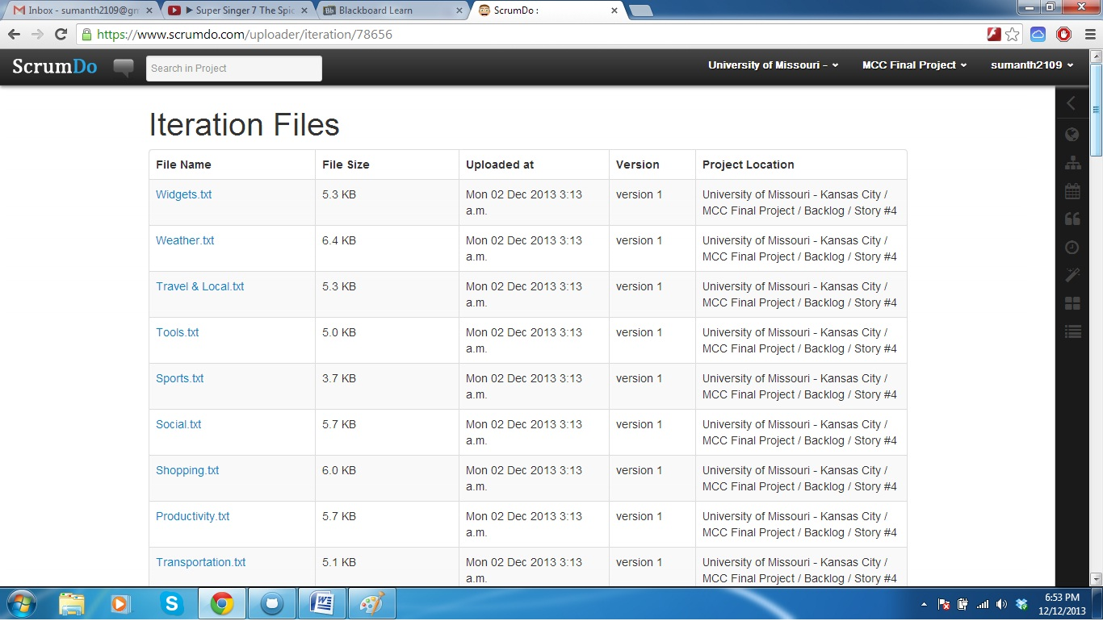

We have also uploaded all the files of each story in the ScrumDo and they can be seen in the above screenshot.

**Final project evaluation:**

App Recommender has been a very innovative project through which we learned advanced technologies like Hadoop, Hadoop ecosystem and Machine learning (Recommendation systems).The final output of project satisfies our original requirements and has brought satisfaction to the team that we have done useful project for our knowledge building. We can improvise on some things like making data dynamic, and recommending top rated apps to users based on their age. But as we could not find any API for the data regarding applications we collected data manually from Google Play store. Also our apps are limited in those particular categories only.

Although from in starting of our project we didn’t have a very clear idea of how the app should work but as we started our research towards the project in a very short time we could figure out how the app should work and by the time we completed our project, it came out very well. We incorporated a lot of agile methodologies into our project management and are satisfied with the result. We followed up iteration after iteration for a better product. We had team meetings at regular intervals synchronizing every team member’s convenience.

From the very beginning of our project we were supported by Dr. Yugyung Lee and Feichen Shen in every aspect of the project. We could easily get over our challenges in the project development from their support.

**Project members Evaluation:**

|  |  |  |  |
| --- | --- | --- | --- |
| Content | Member | Contribution | Total |
| Project Development (80%) | Sumanth Koushik Kalli | 33.3% | 100% |
| Alekhya Boyapati | 33.3% |
| Kamigari Vinil Kumar | 33.3% |
| Final Submission (5%) | Sumanth Koushik Kalli | 33.3% | 100% |
| Alekhya Boyapati | 33.3% |
| Kamigari Vinil Kumar | 33.3% |
| Video Production (8%) | Sumanth Koushik Kalli | 33.3% | 100% |
| Alekhya Boyapati | 33.3% |
| Kamigari Vinil Kumar | 33.3% |
| Others (7%) | Sumanth Koushik Kalli | 33.3% | 100% |
| Alekhya Boyapati | 33.3% |
| Kamigari Vinil Kumar | 33.3% |
| Overall Contribution | Sumanth Koushik Kalli | 33.3% | 100% |
| Alekhya Boyapati | 33.3% |
| Kamigari Vinil Kumar | 33.3% |